Standard Operating Procedure

*Checking Error Logs on Sumo Logic*

## PURPOSE

The purpose of this standard operating procedure (SOP) is to provide a detailed step-by-step procedure to check error logs on Sumo Logic.

## PROCEDURE

1. Log into Sumo Logic:

<https://service.sumologic.com/ui/#/login>

Create a REQ ticket on ServiceNow to an email with username and temporary password.

1. Click on “Log Search” on the home page (in green rectangle):

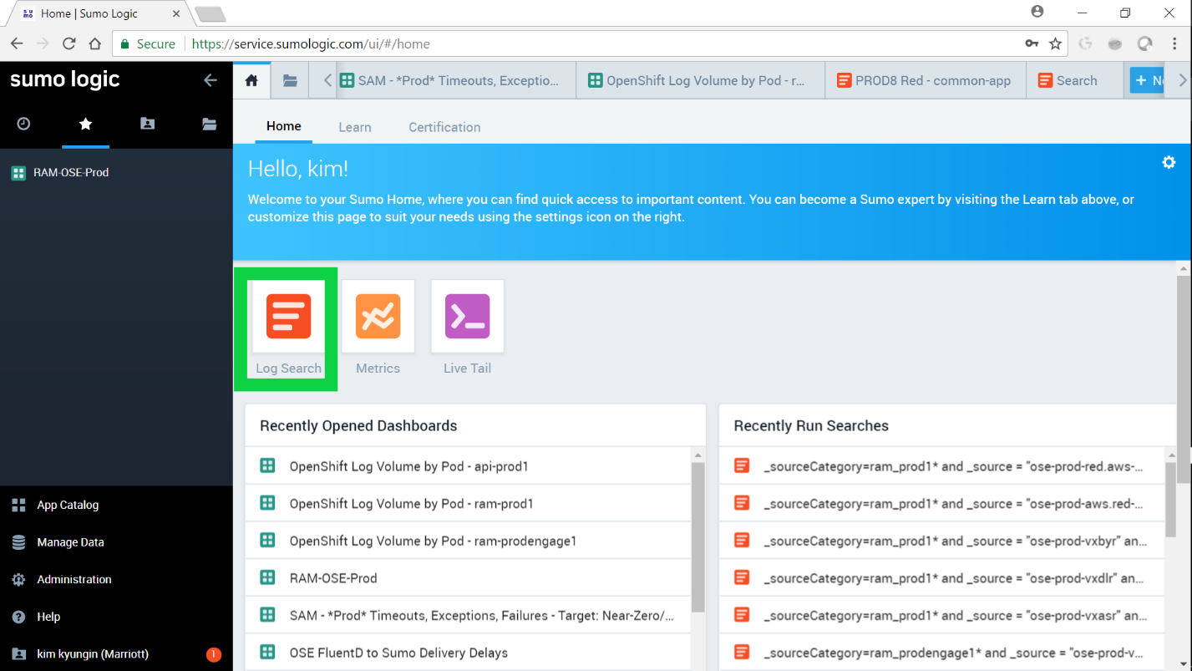

1. Add the query specific for each environment and click on “Start”. i.e. For AWS Prod (Prod 13) Red: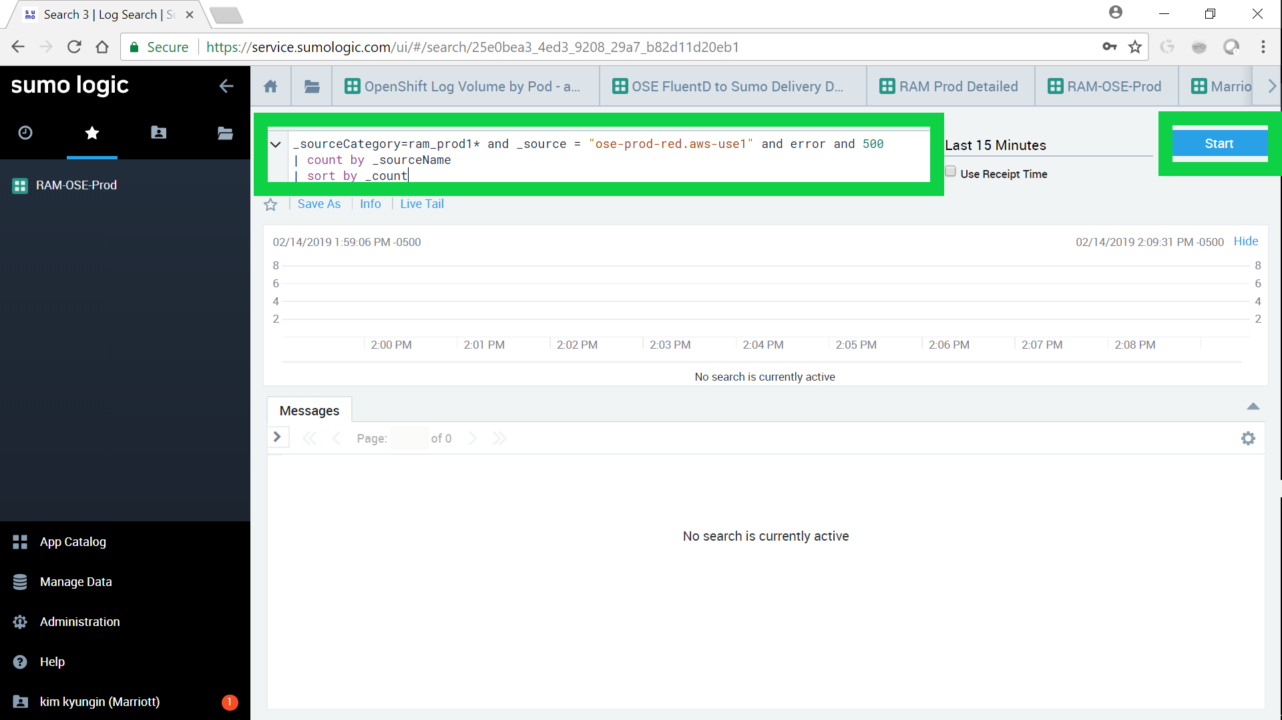

Then app logs should show. High _count number means high 500 errors.

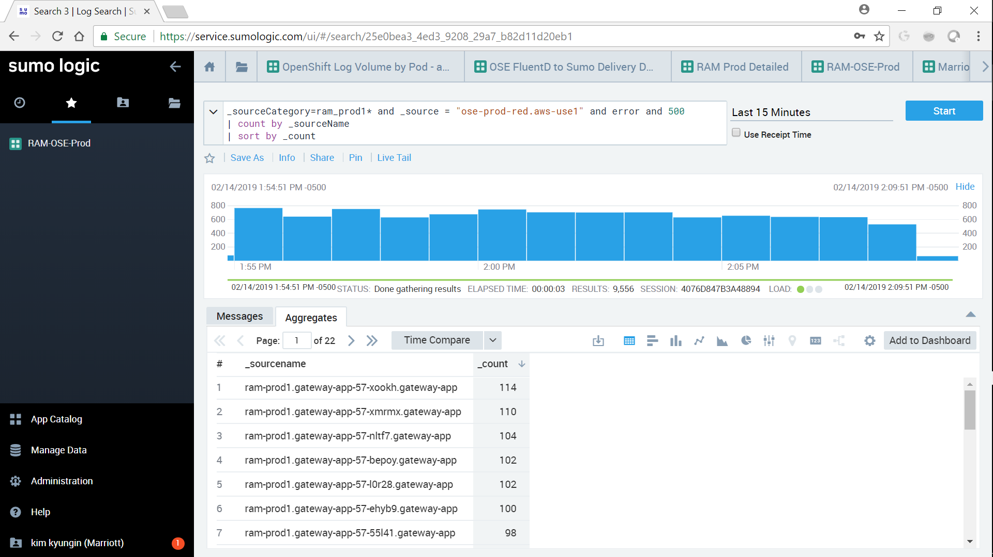

The syntax for the query is:

_sourceCategory=<project name>* and _source = "<environment>" and error and 500

| count by _sourceName

| sort by _count

i.e.:

_sourceCategory=ram_prodengage1* and _source = "ose-prod-vxdlr" and error and 500

| count by _sourceName

| sort by _count

This is checking ram-prodengage1 project in CR Dallas Prod (Prod 10) Red

_sourceCategory=ram_prod1* and _source = "ose-prod-red.aws-use1" and error and 500

| count by _sourceName

| sort by _count

This is checking ram-prod1 project in AWS Prod (Prod 13) Red

## VALIDATION

Follow the validation steps in “Procedure”.

**Document Version Control**

|  |  |  |  |
| --- | --- | --- | --- |
| Version | Effective Date | Reviewed by | Approved by |
| 1.0 | 2/14/2019 | KyungIn Kim | Yashi Kumar |
|  |  |  |  |

Document Modification History & Revision Log

|  |  |  |  |  |  |  |
| --- | --- | --- | --- | --- | --- | --- |
| Version | Date Modified | Revised by | Role | Section Affected | Reference | Remarks |
| 1.0 |  |  |  |  |  |  |
| 1.1 |  |  |  |  |  |  |